**Logging In**

Logging in is quite simple. Just provide the username and password given to you by your instructor. When you have logged in, you will be presented with a list of lessons you have created, organized by date.

**Performance**

Since this application relies on connection to the internet, your iPad **must** be connected to a wifi network when using this application. Networks such as FSUWin may pose problems with the application, so if possible, use a home connection or other wifi connections.



This will appear when any sort of networking processes are running. It may take some time for this notification to disappear, depending on your network.

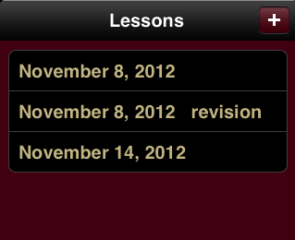**Lesson List (screen may visually change during testing)**

Using this button will allow you to create a new lesson.

Revision means this is a new version of a lesson. In this case, this revision is for November 8th. The old copy is kept for reference.

Selecting a lesson will bring up the Lesson Review screen in the right of the application.

**Lesson Review (screen may visually change during testing)**

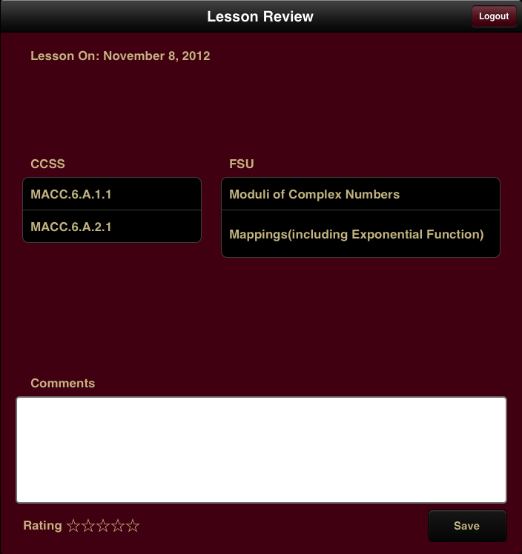Using this button will log you out.

Lesson date is on the left.

CCSS and FSU Standards are listed here for reference for the lesson being taught.

Comments may be added to the lesson by a student or instructor to make changes to the lesson or reflect on performance during lesson.

Lessons can also be rated Comments and Rating **will**

by students or instructors. **only update** if the Save button

is pressed.

**Lesson Creation (screens may visually change during testing)**

By pressing the add button on the Lesson List screen, you will be presented with the Lesson Plan Creation screen.

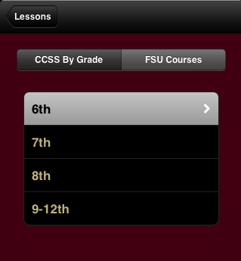Press this to return to your lessons

This will switch you between CCSS and FSU Standards

Selecting a grade here will load the CCSS’s for that grade in the right screen.

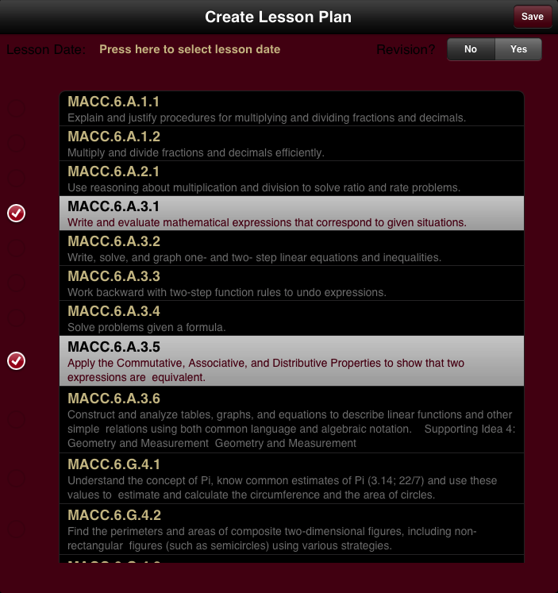Press this button to save. A prompt will let you know it was saved successfully.

Only change this to “Yes” if you are revisioning a past lesson.

Select a lesson date using the provided calendar. Select again to change to a new date.

Select all Standards for lesson.

If any of the necessary areas are left blank, a notification will be displayed.

**Note:** Both CCSS and FSU Standards must be selected in order to save the current lesson. You can switch between the CCSS and FSU Selections.

**Revisions**

Revision was created in order to allow you to be able to reference past lessons in order to create more up to date, correct lessons. If you are adding a revision to a lesson, you **must** recreate the lesson, and you **must** select **Yes** for the label “Revision?”. If not, only a new lesson will be created. Although this is not too big of an issue, it is harder for yourself and your instructor to differentiate between revised/unrevised lessons.